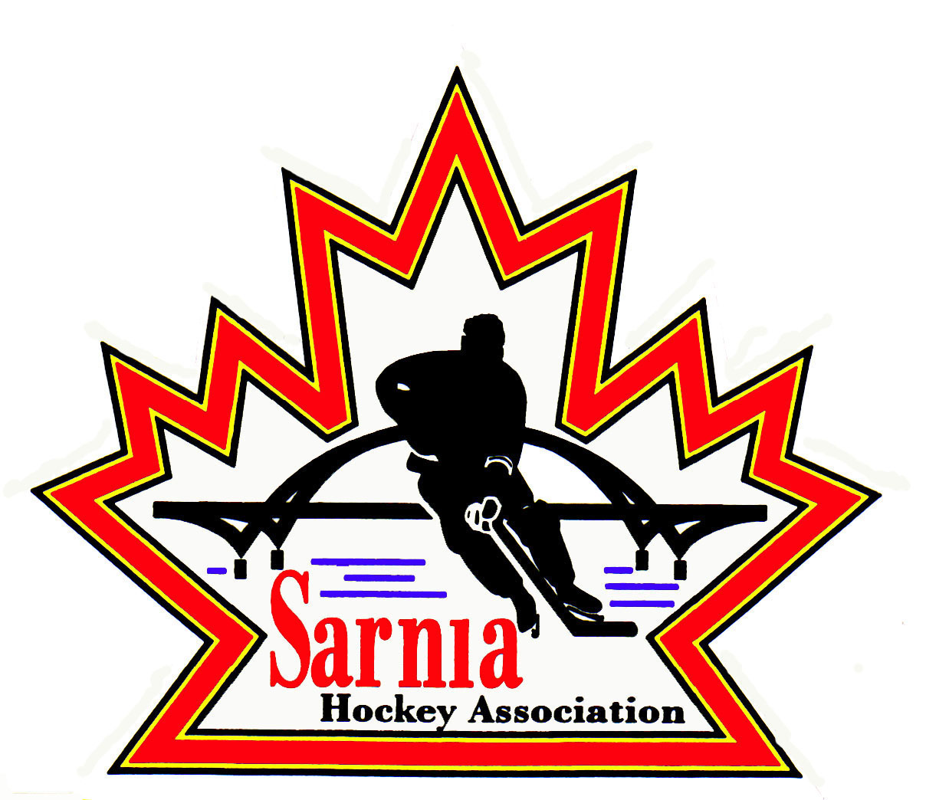

Sarnia Hockey Association

Minutes | Date: SEPTEMBER 2, 2025 | time 7:00 pm

Meeting called by | Paul Walsh, President
Type of meeting | Regular
Secretary | Kelly Lane, Recording Secretary

Welcome | Paul Walsh, President, and meeting Chair welcomed everyone and called the meeting to order at 7:06 pm.

ATTENDANCE | Heather Amaral, Andrew Beasley, Jerry Bernardo, Alister Brown, Emily Brown, Geoff Dale, Paul Douglass, Chuck Ewart, Pat Forbes, Terry Gray, Dan Hunt, Kelly Lane, Cris LaPointe, John Mellor, Nick Mroczek, David Penner, John Ritchie, Jason Teather, Tim Turner, Barb Walsh, Paul Walsh  Regrets: Jacquie Beasley, Ian Dunn, Jeff Fogal, Ryan Gruntz, Linda Lauzon Bonny Marcy, Kyle Mellor, Blake Morrison, Ted Pendle, Carrie Ritchie, Wayne Scarrow

ACCEPTANCE OF MINUTES | MOTION #250902-001  “That the Minutes from August 12, 2025, be accepted as presented.” (E. Brown/A. Beasley)  Carried

TREASURER’S REPORT | Se  MOTION #250902-002  “That the financial Report be accepted as presented.” (E. Brown/J. Ritchie)  Carried  - The August 31 Financial Statement was sent out to the SHA Board via email.  - Starting to see Benevity grant money moving in and out to team accounts.  - We had a healthy month of registration deposits.  - We are still looking to collect $232,000 ($38,000 from Rec, $9400 from A/AA, $7400 from B/BB) and $178,000 for fall teams ($76,000 U18 and $102,000 for MD Teams).  - – most of this is through the Rep Fall tryouts and those fees are not due until later this fall.  - Chasing registration revenue that is past due as of September 1. A good portion of this is through funding.  - Emails were sent to Rep families still owing fees.  - This is the first year we have requested total fees for Rep be paid in May so that process being new could impact this.  - Sponsorship money is coming in.  - $5,561.11 under Registration and Photo Expenses in the financial statement is the fee for credit card transactions.  - Had meeting with Sarnia Lady Jr Sting with the Cousi group. Cousi Golf Tournament raised $35,000 and so there is now a partnership with Lady Sting as well as SHA. A meeting occurred with them to share information about our program. On the days we are running PD Goalie Clinics for our players, the ice after will be used by Lady Sting. There are frequent conversations with that group currently.

BILLS TO BE PAID | MOTION #250902-003  “That the bills be paid as presented.” (E. Brown/Forbes)  Carried
  Recipient | Expense | AMOUNT
  Acme Whistles  Team Outfitters  Dan Hunt  Terry Gray  Terry Gray  Alister Brown | 26 Ref whistles  U9 Jerseys (additional logo work to be paid by sponsor)  Registration expenses  Alliance AGM Travel  U18 AA Tournament deposit (Team loan)  Goalie chest protector and miscellaneous Rec equipment supplies | $ $658.44  $ 8,949.60  $ 90.40  $ 311.40  $ 3,044.00  $ 348.00

PREVIOUS MEETING FOLLOW-UP | STORAGE LOCKERS:  - All three Associations are contributing to the cost of lockers at PASA. One company is doing all of the lockers. An invoice was sent to us. Our bill will be $6300 plus HST. It is timely due to relocation. We may not need all of the lockers, but we have the extra ones for future use. The City has provided approval in writing.  - We had to move the set that was in PASA 2. We also have an area by the AAA U18 locker area that were destroyed during the flood. Due to the Fire Code it had to be moved.  - We could use Google Drives to store the drawing of these lockers so that we have them in future.  MOTION #250902-004  “That we approve the cost of storage lockers at PASA.” (LaPointe/J. Mellor)  Carried

RECREATIONAL  REGISTRAR | REGISTRATION NUMBERS:  FOUNDATIONS SPOTS REMAINING:  U6 - Foundations - 101 registered – 6 on wait list  U7 - Foundations - 31 registered – 1 on wait list  U8 - Foundations - 7 registered  U9 - Foundations - 3 registered  U10 - Foundations - 5 registered  U11 - Foundations - 1 registered  Total Players registered Rep/MD/Foundations/Rec. - 1174 participants  - We will probably have some First Shift players register with SHA after that program ends.  - Trying to get all of the first-time players to complete all of the requirements ie address confirmation, birth certificates, Respect in Sport.  - We had about 40 late registrants.  - Registrar is sending updates to Directors weekly, so they are aware of their numbers.  - U9 Rec has increased to 10 teams.
  DIVISION | AUG 21, 2024 | AUG 8, 2025 | REP 2025
  Foundations | 147 | 148 7 on wait | U8 MD 29
  U7 | 94 | 108 10 remaining | U9 MD 50
  U9 | 161 | 137 7 remaining | U10-U16 AA 119
  U11 | 155 | 112 24 remaining | U10-U16 BB 119
  U13 | 173 | 110 26 remaining | U18 AA
  U15 | 164 | 89 19 remaining | U18 BB 25
  U16-U18 | 175 | 121 23 remaining
  U21 | 31 |  | TOTAL REP and MD/REP
   |  |  | (TRYOUTS)
   | TOTAL 1100 | TOTAL 677 | 342

VICE-PRESIDENT REPRESENTATIVE TEAMS | REP COUNCIL MEETING:  - There was discussion about the changes to suspensions.  - There is more specific detail on Intent to Injury penalties.  - Change in Checking From Behind minor is now 2 games. The major is accelerated by one game each. First offence is 3 and second is 4 etc. Making stiffer penalties.  - More games for hooking injury, interference - all increased to 2 games.  - Attempt to injury penalties are broken out further.  - They presented the draft version, and it will be on Alliance website.  - OHF Music policy was discussed. There were a lot of complaints about music in dressing rooms. It is not just the volume but the content (offensive language). The new policy indicates that the music has to be radio friendly. There will be penalties, and the coach can be suspended for infractions.  VSC REQUIREMENTS:  - As of August 1, receipt for VSC can be submitted. OPP is up to 3 months to get VSC back.  - When you log on to submit your VSC you can submit your receipt. With out that you can’t go on the roster. Can be on roster without a valid VSC as long as the receipt is submitted.  NON -SANCTIONED GAME PLAY:  - U8/9 playing non sanction league games was voted down. Ban is still in effect.  - High School hockey is Hockey Canada sanctioned.  GREEN ARM BAND POLICY:  - Green arm bands are worn by minor aged referees. Anyone who is under 18 wears a green arm band. This year moving it into Rep and making it mandatory for minor aged refs to wear green arm band for those games as well.  ALLIANCE MANUAL OF OPERATIONS:  - Alliance Hockey has updated their Manual of Operations, and it should be on their website soon.  - We will have updates to our policies once it is released.  SURVEYS:  - Surveys were sent out re Movement and ITP process. Presented feedback on affiliation process. A lot of people were not in favour of it. New process – allowed to affiliate to as many teams as you want, but players have to follow the division and class restrictions. Still remains at 10 games and Select is 5 games.  - Most teams that AP don’t use more than 3 or 4 players. We can add restrictions if we want.  - We are going to stick with the AP roster forms as it was beneficial for communication. Parents and coaches from both teams have to sign. They will then be on roster.  - Exhibition games and tournaments don’t count in the numbers.  - Commitment to the player’s primary teams still takes precedence.  U8/9 MD STRUCTURE:  - There are no changes for U8 MD. They still remain ½ ice for the entire season and 18 on roster with 2 goalies.  - For U9 Rep, approval was received from Hockey Canada to modify. Development phase is now 60 days. There are no league games during the development phase, but teams are allowed to be in 1 Jamboree and play exhibition games. Two practices to 1 game. This is for Tier 1 and 2 MD.  - Starting November 1, they will move to full ice. No regular season in half ice.  - They will be calling penalties but will not be using specialty teams. The play remains 5 on 5. Player gets penalized not the team. They don’t want players to learn power play and penalty kill until the following year.

REC STEERING COMMITTEE | - As per SHA Policy, SHA Board members that want to be head coaches of teams need to be identified and approved by the Board.  MOTION #250902-005  “The following SHA Board Members have been approved to be Head Coach for a Rec Team: Jeff Dale, Dan Hunt, Pat Forbes and Nick Mroczek.” (Bernardo/Turner)  Carried  U18  - We have had some interest in U18 – 2007 birth year. We have had 3 requests.  - We are looking for board approval for these over age players.  - Looking to allow 1 per team of 2007 birth year as long as they played in SHA last year with the understanding, they may not be eligible to attend tournaments or Championship. Also has to be room on that team.  - We did this a few years ago and there were no issues. We limit to one per team.  - Currently we are looking at 15 players per team plus goalies. We are fine if we let 1 over aged player per team.  - We have 23 spots currently available in that division.  MOTION #250902-006  “That SHA allow 1 U18 Rec team (2007 born players) for the 2025/26 season as long as there is room in the division and player has been a member of SHA and played in SHA last season. They can also play in any tournament as long as permission is received from the tournament director.” (Bernardo/Hunt)  Carried (12 for and 5 opposed)  - These over aged players cannot register but will be put on a wait list.  - We will put this information on our SHA website in mid-September and list the criteria as discussed. We are willing to accept 8 over aged players.

ICE DIRECTOR | - Most of the AA games are scheduled  - BB is in process of finalizing.  - MD will start once Alliance decides divisions.  - U9 Tier 2 is up in the air. Forming east and west divisions.  - Push back by Burlington as their teams not wanting to drive to Sarnia.  - Clearwater Blue Arena update provided. The boards are not in, but we are told that it will be open on Sept 18. We have 5 hours a night at this arena, so we are limited in ice availability.  - Our rep teams are in development phase until Sept 29. They are allowed 1 tournament and 2 exhibition games.  - Ice Director is building rep team ice and giving teams ice that have games/tournaments – trying to give one practice per week.  - We are running evaluation skates for U8 and U9.

CLINICS | - Working on body checking and refresher clinics.  - Majority of players had it, but due to player movement we didn’t know if outside players had it.  - We offered one in the Spring, and it was full.  - We had to turn away players in the Spring, so we are offering one in the fall for the AP’s.  - Alliance requires us to run a refresher clinic prior to December. It will be done during team’s practices.  - We have someone that can facilitate the clinic so it can be scheduled at their availability.  - U14 AA and above Coaches need to be D1 certified which includes a field evaluation. We have an Evaluator in our Association that is able to do D1 certifications.

NEW BUSINESS | NEXT MEETING:  - Next meeting is Wednesday, September 17, 2025 at Clearwater Arena.

adjournment | MOTION #250902-007  “That the meeting be adjourned.” (Hunt/Douglass)  Carried

Paul Walsh Kelly Lane
President Secretary

